Project Design Phase-II Technology Stack (Architecture & Stack)

Date | 31 January 3035
Team ID
Project Name | Visualizing Housing Market Trends: An Analysis of Sale Prices and Features using Tableau
Maximum Marks | 4 Marks

Technical Architecture:
The Deliverable shall include the architectural diagram as below and the information as per the table1 & table 2

Example:

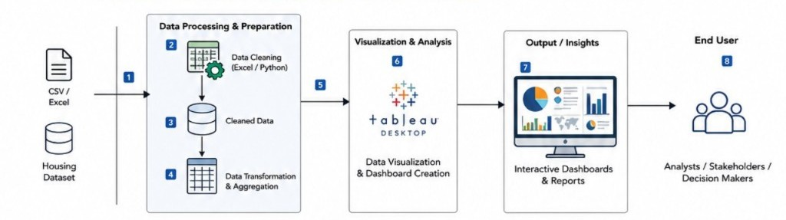

Table 1 : components and technologies
S.No | Component | Description | Technology
1 | Front-End Dashboard | Interactive dashboards and visualizations for housing  market analysis
2. | Application Logic-1 | Data cleaning, preprocessing, and transformation of housing datasets | Java / Python
3. | Application Logic-2 | Statistical analysis and feature correlation analysis | IBM Watson STT service
4. | Application Logic-3 | Data integration and dashboard interaction logic | IBM Watson Assistant
5. | Database | Storage of housing datasets and processed data | MySQL, NoSQL, etc.
6. | Cloud Database | Cloud storage and data sharing services | IBM DB2, IBM Cloudant etc.
7. | File Storage | Storage of datasets, reports, dashboards, and project files | IBM Block Storage or Other Storage Service or Local Filesystem
8. | External API-1 | Housing and real estate data collection (if required) | IBM Weather API, etc.
9. | External API-2 | Geographical and location-based data visualisation | Aadhar API, etc.
10. | Machine Learning Model | Predictive analysis of housing prices and market trends (optional) | Object Recognition Model, etc.
11. | Infrastructure (Server / Cloud) | Deployment and publishing of dashboards and reports | Local, Cloud Foundry, Kubernetes, etc.

Table-2: Application Characteristics:

S.No | Characteristics | Description | Technology
1. | Open-Source Frameworks | Open-source libraries used for data preprocessing, analysis, and visualization support. | Python, Pandas, NumPy, Matplotlib, Seaborn
2. | Security Implementations | Secure handling of datasets and controlled access to dashboards and reports. | Tableau User Authentication, Role-Based Access Control  (RBAC), HTTPS Encryption
3. | Scalable Architecture | The system can accommodate larger housing datasets and additional visualizations without major architectural changes. | Tableau Cloud, Modular Dashboard Design, Python-based Data Processing
4. | Availability | Dashboards and reports are accessible online and can be shared with multiple users at any  time. | Tableau Public/Tableau Cloud, Cloud Storage Services
5 | Performance | Efficient processing and visualization of housing data with optimized queries and interactive filters for faster response times. | Tableau Extracts (.hyper), Data Caching, Python Data Optimization Techniques

